|  |  |
| --- | --- |
| **Ex. No: 1** | **Design a responsive layout for a societal (social) application** |
| **Date:** |

### Aim :

To Design a responsive layout for a societal (social) application.

### Implementation:

Design a responsive layout for a societal (social) application requires careful consideration of various factors to ensure a seamless user experience across different devices.

1. Define Goals and User Requirements:
   * Clearly outline the goals of your societal application and understand the needs of your target users.
   * Identify key features and prioritize them based on user requirements.
2. Understand the Target Audience:
   * Create user personas to understand the characteristics, preferences, and behaviors of your target audience.
   * Consider factors such as age, demographics, and technological proficiency.
3. Mobile-First Approach:
   * Begin the design process with a mobile-first approach, focusing on designing for smaller screens.
   * Prioritize content and features based on their importance to mobile users.
4. Responsive Grid System:
   * Utilize a responsive grid system to structure your layout.
   * Define how the layout will adapt to different screen sizes and orientations.
5. Media Queries:
   * Implement CSS media queries to apply styles based on different screen sizes.
   * Set breakpoints to define when the layout or styling should change.
6. Flexible Images and Media:
   * Use responsive image techniques to ensure images scale appropriately on different devices.
   * Consider the use of CSS properties like `max-width: 100%;` to prevent images from overflowing.
7. Typography and Readability:
   * Optimize typography for readability on various screen sizes.
   * Use relative units for font sizes and line heights to allow for flexibility.
8. Navigation Design:
   * Design an intuitive and user-friendly navigation system.
   * Consider mobile-friendly navigation patterns, such as hamburger menus for smaller screens.
9. Touch-Friendly Interactions:
   * Optimize interactive elements for touch devices.
   * Ensure buttons and other interactive elements are appropriately sized for touch input.
10. Consistent Branding:
    * Maintain consistent branding elements across different devices.
    * Ensure that colors, logos, and other branding elements are displayed effectively.
11. Performance Optimization:
    * Optimize assets (images, scripts, styles) for faster loading times, especially on mobile networks.
    * Implement lazy loading for images to improve initial page load speed.
12. Usability Testing:
    * Test the responsive design on various devices and screen sizes.
    * Gather feedback from real users to identify any usability issues and make necessary adjustments.
13. Cross-Browser Compatibility:
    * Ensure that the responsive layout works consistently across different web browsers.
    * Test on popular browsers such as Chrome, Firefox, Safari, and Edge.
14. Accessibility:
    * Design with accessibility in mind to ensure the application is usable by individuals with disabilities.
    * Follow web accessibility standards and guidelines.
15. Documentation and Guidelines:
    * Document the responsive design guidelines for your application.
    * Provide documentation for developers, including coding standards and best practices.
16. Iterative Design:
    * Embrace an iterative design process, making refinements based on user feedback and changing requirements.
    * Stay adaptable and open to continuous improvement.

### Output:

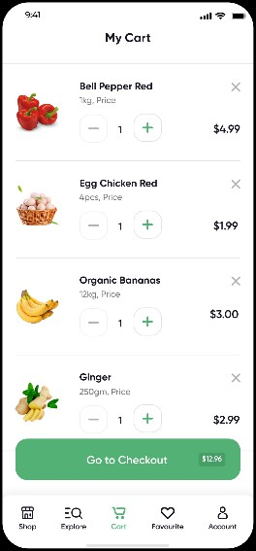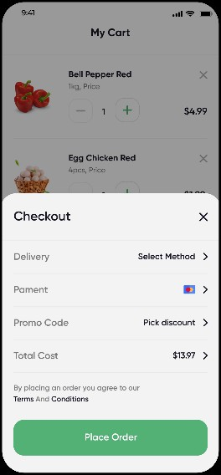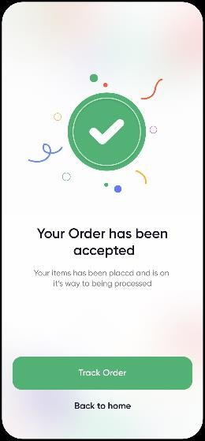

|  |  |  |
| --- | --- | --- |
| **DEPARTMENT OF CSE** | | |
| Performance | 30 |  |
| Observation | 30 |  |
| Record | 40 |  |
| Total | 100 |  |

**Result:**

Thus the responsive layout for a societal (social) application were designed successfully.

|  |  |
| --- | --- |
| **Ex. No: 2** | **UI interaction patterns** |
| **Date:** |

### Aim:

To understand the various UI interaction patterns that designers commonly used to create engaging and intuitive user interfaces.

### Implementation & Understandings:

1. Click/Tap:
   * Basic interaction where users click or tap on elements to trigger an action.
2. Double Click/Double Tap:
   * Triggering an action or behavior by quickly clicking or tapping twice.
3. Hover:
   * Displaying additional information or actions when the user hovers over an element, often used in desktop interfaces.
4. Scrolling:
   * Vertical or horizontal movement through content using a scroll wheel, touch gesture, or scrollbar.
5. Swipe:
   * Horizontal or vertical gesture on a touch-enabled device to navigate through content or trigger actions.
6. Pinch:
   * Gesture involving two fingers, often used for zooming in or out on touchscreens.
7. Drag and Drop:
   * Users drag an element and drop it in a different location to perform an action, such as reordering items.
8. Accordion:
   * Expanding and collapsing content sections to conserve space and provide a more organized view.
9. Carousel:
   * A rotating set of images or content displayed in a sequential manner, often used for showcasing multiple items in a limited space.
10. Modal/Overlay:
    * Displaying additional content or features in a layered window that temporarily overlays the main interface.
11. Tabs:
    * Organizing content into multiple sections, allowing users to switch between them.
12. Dropdown Menu:
    * A menu that appears when users click or hover over a designated area, providing a list of options.
13. Toggle Switch:
    * A binary switch that users can toggle on or off to activate or deactivate a feature.
14. Radio Buttons:
    * A set of options where users can choose only one, often used in forms.
15. Checkbox:
    * A selection control that allows users to choose multiple options, often used in forms.
16. Stepper/Incrementor:
    * A control that allows users to increase or decrease a numerical value incrementally.
17. Progress Indicator:
    * Showing the progress of a task or process, often with a loading spinner or progress bar.
18. Sliders:
    * Allowing users to select a value within a range by dragging a slider handle.
19. Pagination:
    * Dividing content into separate pages, often used for long lists or articles.
20. Breadcrumbs:
    * Navigational aid showing the user's location within a hierarchical structure.
21. Search Box:
    * Allowing users to input search queries to find specific information within the interface.
22. Notification/Alert:
    * Displaying important messages or alerts to users, often in a temporary overlay or as a banner.
23. Tooltip:
    * Providing additional information when users hover over or click on a specific element.
24. Menu Icon/Hamburger Menu:
    * A compact menu that expands when clicked or tapped, often represented by three horizontal lines.
25. Context Menu:
    * A menu that appears when users right-click or long-press on an element, offering context-specific options.

### Output:

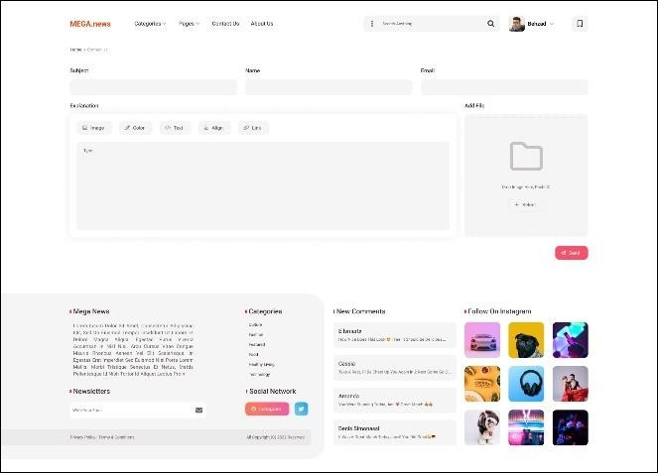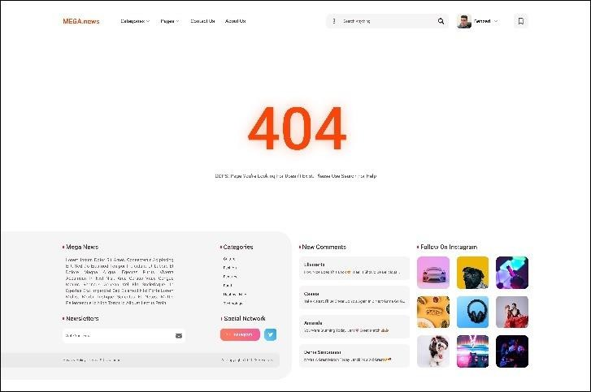

|  |  |  |
| --- | --- | --- |
| **DEPARTMENT OF CSE** | | |
| Performance | 30 |  |
| Observation | 30 |  |
| Record | 40 |  |
| Total | 100 |  |

**Result:**

Thus the various UI interaction patterns that commonly used to create engaging and intuitive user interfaces were designed successfully.

|  |  |
| --- | --- |
| **Ex. No: 3** | **Cohesive and Effective UI style** |
| **Date:** |

### Aim:

To Create a cohesive and effective UI style involves adhering to certain design guidelines.

### Implementation & Understandings:

1. Consistency:
   * Maintain a consistent visual language throughout the interface, including colors, typography, and iconography.
   * Consistency helps users predict the appearance and behavior of UI elements.
2. Clarity:
   * Ensure that the UI elements are clear and easy to understand.
   * Use concise and meaningful labels for buttons and navigation elements.
3. Hierarchy:
   * Establish a clear visual hierarchy to guide users through the content.
   * Prioritize important elements with size, color, and placement.
4. Whitespace:
   * Use whitespace generously to create a clean and uncluttered interface.
   * Adequate spacing improves readability and reduces cognitive load.
5. Typography:
   * Choose legible fonts for body text and headings.
   * Maintain a limited number of font styles to avoid visual clutter.
6. Color Scheme:
   * Select a harmonious color scheme that aligns with your brand and creates a visually pleasing experience.
   * Use color to convey meaning, such as highlighting important actions or indicating status.
7. Responsive Design:
   * Design for various screen sizes and resolutions to ensure a consistent user experience across devices.
   * Test the responsiveness of your design on different devices.
8. Feedback:
   * Provide visual feedback for user interactions, such as button presses or form submissions.
   * Use animations or color changes to indicate system responses.
9. Accessibility:
   * Design with accessibility in mind, ensuring that the interface is usable by individuals with disabilities.
   * Consider contrast ratios, text legibility, and keyboard navigation.
10. Iconography:
    * Use clear and recognizable icons to represent actions or information.
    * Ensure that icons are consistent in style and easily understood by users.
11. Navigation:
    * Design intuitive and user-friendly navigation systems.
    * Clearly indicate the user's current location within the interface.
12. Button Design:
    * Ensure buttons are easily clickable with appropriate size and spacing.
    * Use consistent styling for primary and secondary actions.
13. Forms and Input Fields:
    * Clearly label input fields and provide helpful hints or placeholders.
    * Group related form elements logically.
14. Loading Indicators:
    * Use loading indicators to inform users of ongoing processes.
    * Provide feedback on the progress of tasks.
15. Error Handling:
    * Clearly communicate errors to users with informative messages.
    * Offer guidance on how to correct mistakes in forms or interactions.
16. Microinteractions:
    * Implement subtle animations or microinteractions to enhance the user experience.
    * Ensure that these interactions contribute positively to usability.
17. Testing:
    * Regularly test your UI design with real users to gather feedback.
    * Conduct usability testing to identify areas for improvement.
18. Documentation:
    * Document your UI style guidelines to maintain consistency across the design.
    * Include guidelines for developers and other team members involved in implementing the UI.

### Output:

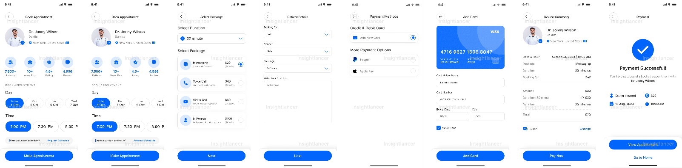

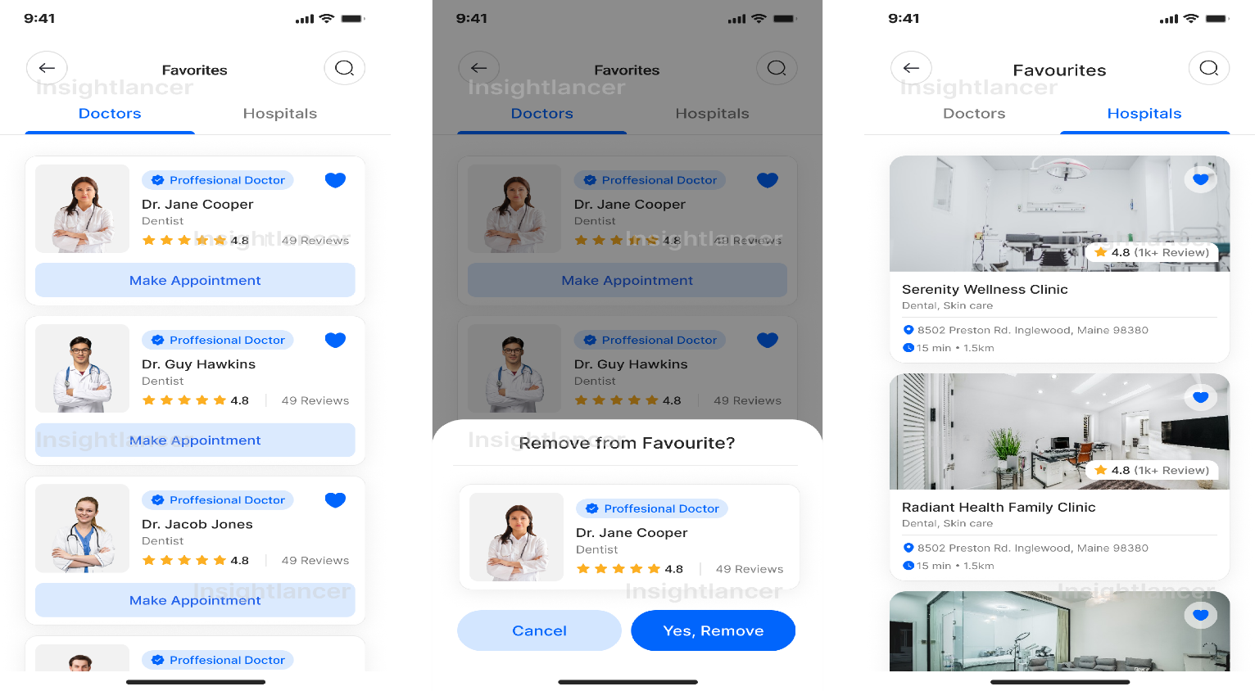

|  |  |  |
| --- | --- | --- |
| **DEPARTMENT OF CSE** | | |
| Performance | 30 |  |
| Observation | 30 |  |
| Record | 40 |  |
| Total | 100 |  |

**Result:**

Thus the cohesive and effective UI style involves adhering were created successfully.

|  |  |
| --- | --- |
| **Ex. No: 4** | **Designing a wireframe in Figma** |
| **Date:** |

### Aim:

To Design a wireframe in for a visual representation of the layout and structure of a digital interface

### Implementation & Understandings:

1. Define the Scope and Goals:
   * Clearly understand the purpose of the wireframe and the goals you aim to achieve.
   * Identify key features and content that need to be represented.
2. Gather Requirements:
   * Collect requirements from stakeholders and consider user needs.
   * Identify essential elements such as navigation, content areas, and interactive components.
3. Create a New Figma File:
   * Open Figma and create a new project or file for your wireframe.
   * Define the canvas size based on the type of interface you are designing (e.g., desktop, mobile).
4. Add Basic Shapes for Containers:
   * Use Figma's shape tools to create basic containers for key sections of the interface.
   * Represent main content areas, headers, footers, and sidebars.
5. Establish a Grid System:
   * Set up a grid system to ensure alignment and consistency.
   * Define column widths and spacing based on your design preferences.
6. Placeholder Text and Images:
   * Use placeholder text and images to represent content without getting into details.
   * Focus on the overall structure and layout rather than specific content.
7. Navigation Elements:
   * Add placeholders for navigation elements such as menus, buttons, and links.
   * Represent the overall navigation flow and hierarchy.
8. Typography and Basic Styling:
   * Add basic typography elements for headings, subheadings, and body text.
   * Apply simple styling to distinguish between different types of content.
9. Input Fields and Forms:
   * Include input fields, checkboxes, and buttons to represent form elements.
   * Show the layout and arrangement of form components without detailing specific form fields.
10. Icons and Symbols:
    * Integrate icons or symbols to represent actions or key features.
    * Keep them simple and focused on conveying meaning.
11. Feedback and Interaction:
    * Indicate feedback and interactive elements, such as buttons that change appearance when hovered.
    * Represent basic user interactions without intricate details.
12. Footer and Additional Elements:
    * Add a footer if applicable, and include any additional elements necessary for your design.
    * Keep the wireframe focused on the core structure and functionality.
13. Annotations:
    * Include annotations or notes to explain specific elements or functionalities.
    * Clarify any design decisions that might not be immediately evident.
14. Review and Iterate:
    * Review the wireframe and gather feedback from stakeholders or team members.
    * Iterate on the design based on the feedback received.
15. Export or Share:
    * Export the wireframe as needed for documentation or presentation purposes.
    * Share the Figma file with collaborators for further discussions and iterations.
16. High-Fidelity Design (Optional):
    * If your wireframe is part of a larger design process, consider transitioning to a high-fidelity design in Figma once the wireframe is approved.

### Output:

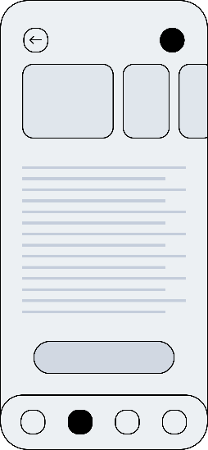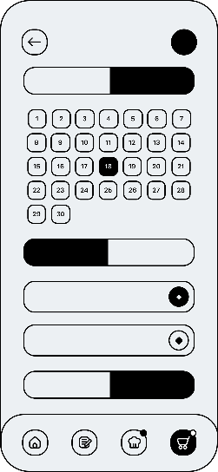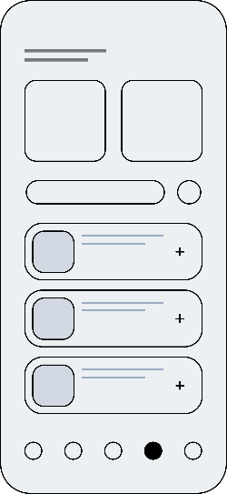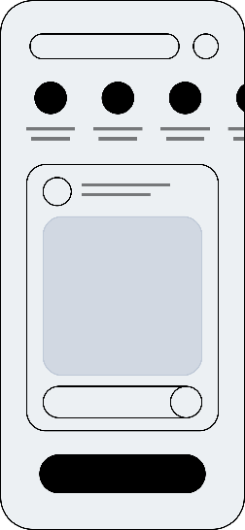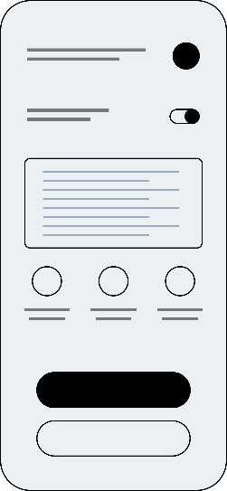

|  |  |  |
| --- | --- | --- |
| **DEPARTMENT OF CSE** | | |
| Performance | 30 |  |
| Observation | 30 |  |
| Record | 40 |  |
| Total | 100 |  |

**Result:**

Thus the wireframe in for a visual representation of the layout and structure of a digital interface was designed successfully.

|  |  |
| --- | --- |
| **Ex. No: 5** | **Exploring various open-source collaborative interface Platform** |
| **Date:** |

Aim:

To explore the various open-source collaborative interface Platform.

1. Figma:
   * While Figma itself is not open source, it is a popular cloud-based design tool with collaborative features. There are efforts to create open-source alternatives inspired by Figma, such as [penpot](https://penpot.app/).
2. Inkscape:
   * Inkscape is an open-source vector graphics editor that supports collaborative design work. It might be used in combination with version control systems for collaboration.
3. Gravit Designer:
   * Gravit Designer is a vector design tool that offers both cloud-based and desktop versions. It has collaboration features, and the desktop version is available as open source.
4. Vectr:
   * Vectr is a free and open-source vector graphics editor with real-time collaboration features. It allows users to work together on the same design in real-time.
5. Wireflow:
   * Wireflow is an open-source tool for creating wireframes and user flows. It's designed to be collaborative and allows multiple users to work on a project simultaneously.
6. Pencil Project:
   * Pencil Project is an open-source GUI prototyping tool that supports both desktop and web-based platforms. It's suitable for creating diagrams, user interfaces, and wireframes.
7. Drawpile:
   * Drawpile is a collaborative drawing platform where multiple users can sketch on the same canvas in real- time. While it's more focused on drawing, it can be used for collaborative creative work.
8. Whiteboard:
   * Whiteboard is an open-source real-time collaborative drawing tool. It allows multiple users to draw and annotate together on a shared canvas.

### Output:

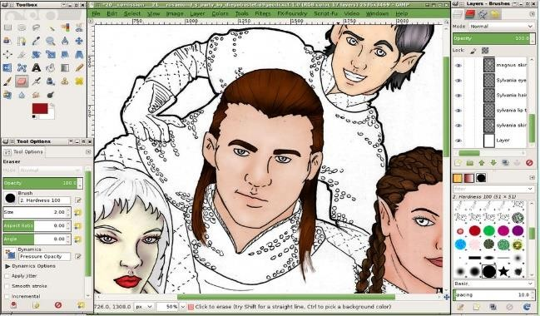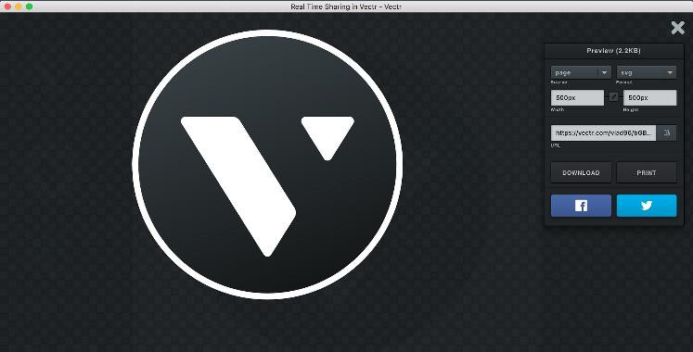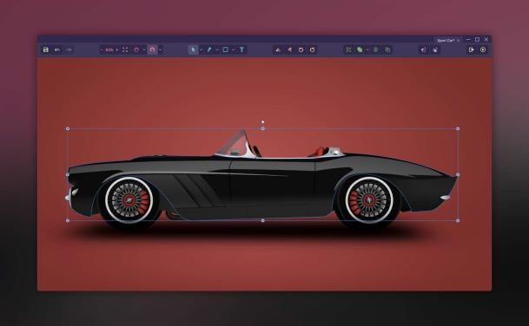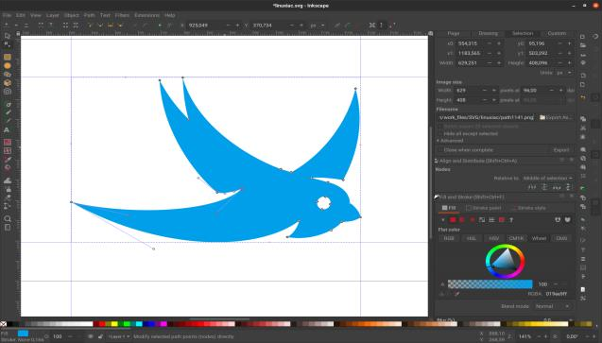

|  |  |  |
| --- | --- | --- |
| **DEPARTMENT OF CSE** | | |
| Performance | 30 |  |
| Observation | 30 |  |
| Record | 40 |  |
| Total | 100 |  |

**Result:**

Thus the various open-source collaborative interface Platform were successfully explored.

|  |  |
| --- | --- |
| **Ex. No: 6** | **Design Thinking Process** |
| **Date:** |

### Aim:

To Design an eCommerce mobile app using the Design Thinking process involves understanding the users' needs, exploring possibilities, and iteratively refining the solution.

### Implementation and Understandings:

1. Empathize:
   1. User Research:
      * Conduct interviews, surveys, and observations to understand the shopping behaviors and preferences of your target audience.
      * Identify pain points and challenges users face when shopping online.
   2. Create User Personas:
      * Develop detailed user personas representing different segments of your target audience.
      * Understand their goals, motivations, and potential obstacles in using an eCommerce app.
2. Define:
   1. Problem Statement:
      * Based on user research, articulate a clear problem statement that your eCommerce app aims to solve.
      * For example, "How might we simplify the online shopping experience for busy professionals?"
   2. User Journey Mapping:
      * Map out the user journey from product discovery to checkout.
      * Identify touchpoints and potential areas for improvement in the user experience.
3. Ideate:
   1. Brainstorming:
      * Organize brainstorming sessions with your team to generate ideas for addressing the identified problems.
      * Encourage a diverse range of ideas without judgment.
   2. Feature Prioritization:
      * Prioritize features based on user needs, business goals, and technical feasibility.
      * Identify features that can enhance the overall shopping experience.
   3. Storyboarding:
      * Create storyboards to visualize how users might interact with your app.
      * Highlight key features and touchpoints in the user journey.
4. Prototype:
   1. Low-Fidelity Prototypes:
      * Develop low-fidelity prototypes using tools like Figma or Sketch.
      * Focus on the layout, navigation, and basic interactions.
   2. Usability Testing:
      * Conduct usability testing with potential users to gather feedback on the initial prototype.
      * Identify areas for improvement and refinement.
   3. Iterative Prototyping:
      * Iterate on the prototype based on user feedback and insights from usability testing.
      * Refine the design and interactions to address user concerns.
5. Test:
   1. High-Fidelity Prototypes:
      * Develop high-fidelity prototypes with more refined visuals and interactions.
      * Test the prototype with a larger group of users to gather comprehensive feedback.
   2. A/B Testing:
      * Implement A/B testing to compare different design variations and identify the most effective solutions.
      * Test elements like button placements, color schemes, and navigation options.
6. Implement:
   1. Development:
      * Collaborate with developers to implement the finalized design into the actual eCommerce mobile app.
      * Ensure that the design is translated accurately into the development phase.
   2. Continuous Feedback:
      * Maintain open communication with the development team, gather feedback during implementation, and address any unforeseen challenges.
7. Launch:
   1. Soft Launch:
      * Consider a soft launch to a smaller audience to gather additional feedback before a full-scale release.
      * Monitor user behavior and identify any issues that may arise in a real-world scenario.
   2. Marketing:
      * Develop a marketing strategy to promote the app's launch.
      * Highlight key features and benefits to attract users.
8. Iterate:
   1. User Feedback:
      * Continue gathering user feedback post-launch.
      * Implement regular updates and improvements based on user reviews, ratings, and analytics data.
   2. Continuous Improvement:
      * Embrace a mindset of continuous improvement, with regular iterations to enhance the app's features and user experience.

### Output:

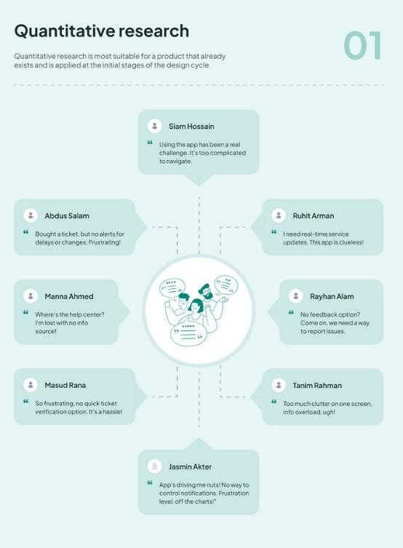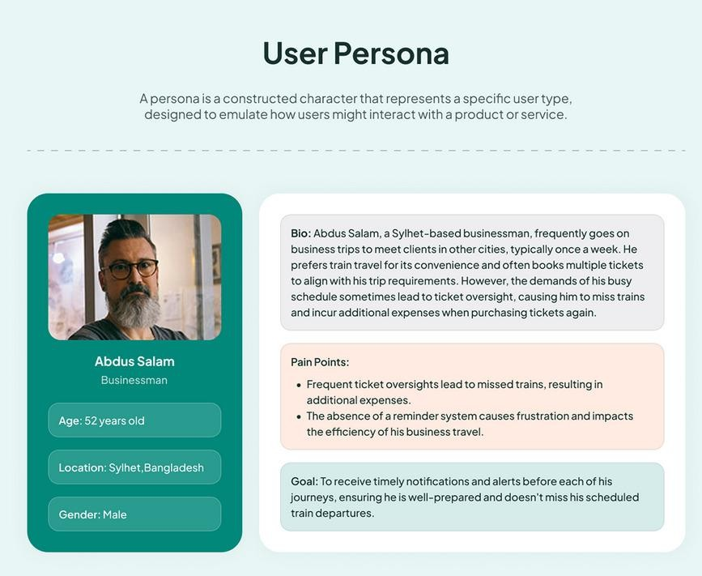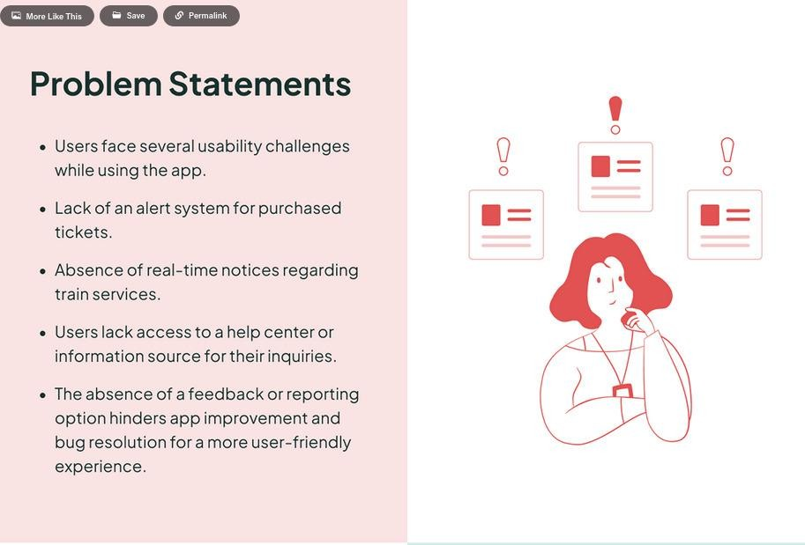

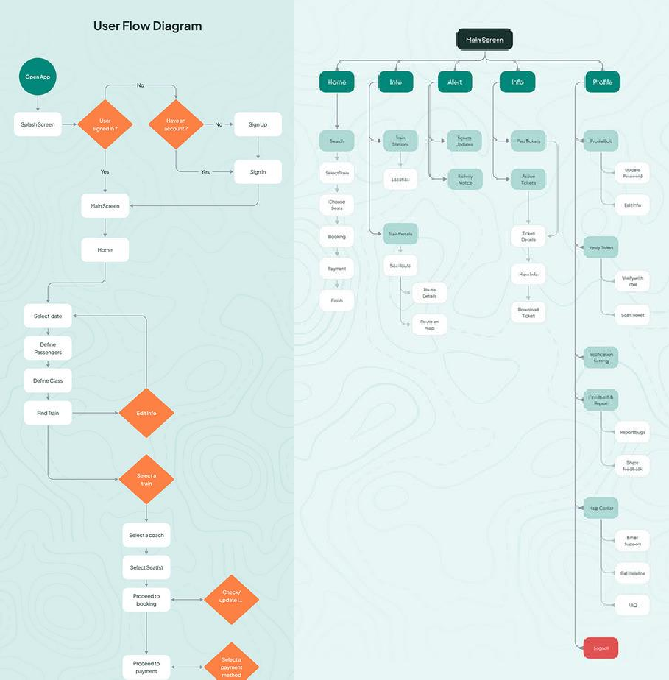**:**

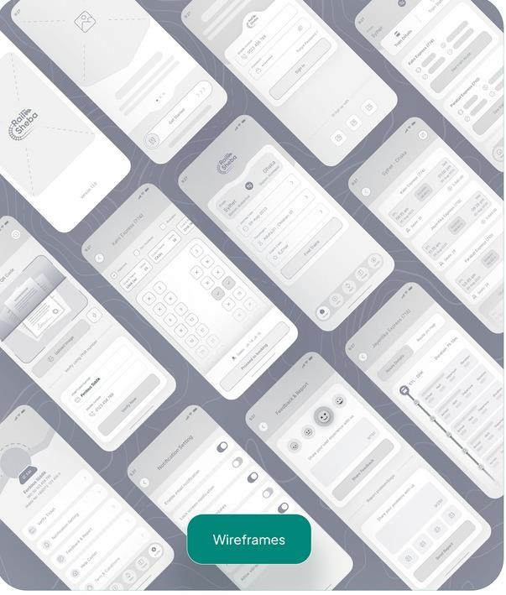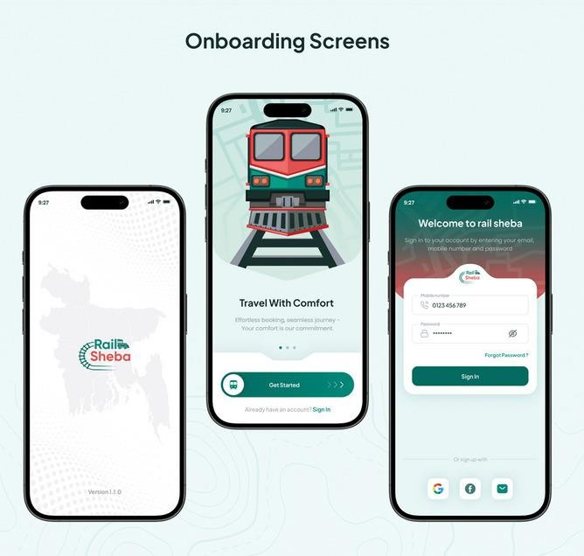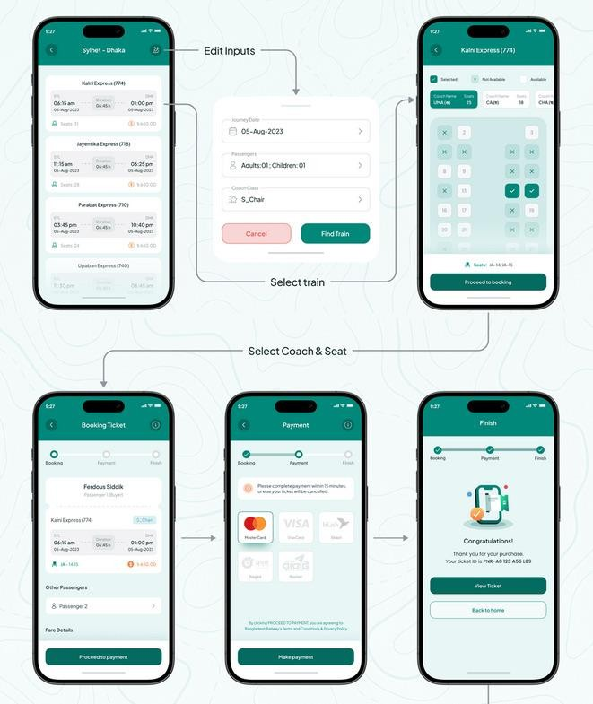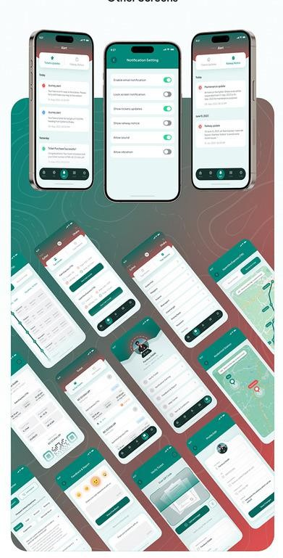

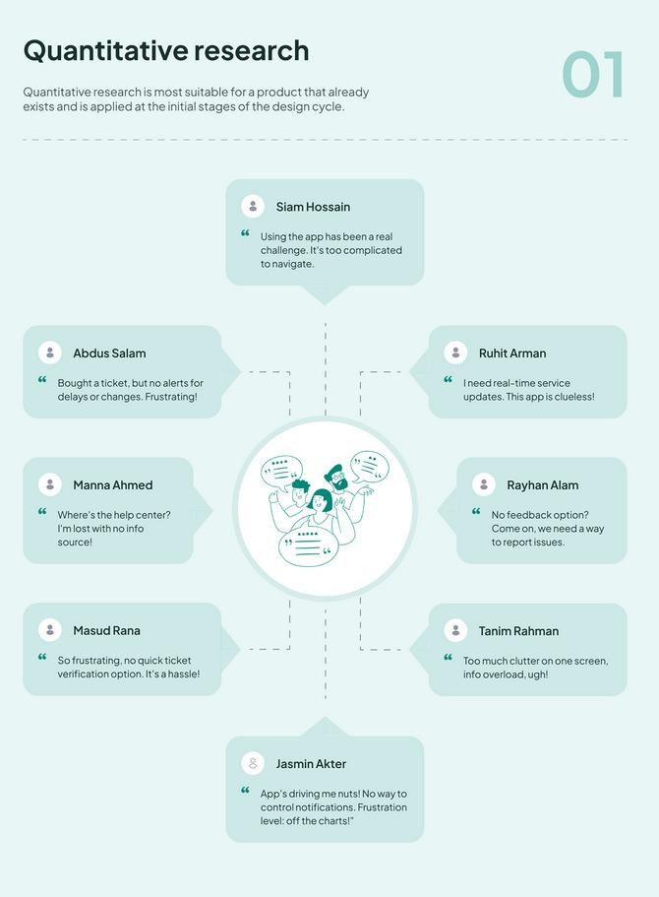

|  |  |  |
| --- | --- | --- |
| **DEPARTMENT OF CSE** | | |
| Performance | 30 |  |
| Observation | 30 |  |
| Record | 40 |  |
| Total | 100 |  |

### Result:

Thus an eCommerce mobile app using the Design Thinking process were designed successfully.

|  |  |
| --- | --- |
| **Ex. No: 7** | **Brainstorming Practises** |
| **Date:** |

### Aim:

To understand the importance and practises of brainstorming for a web application. Implementation:

User-Centric Considerations:

1. User Personas:
   * Brainstorm different user personas based on your target audience.
   * Consider the goals, preferences, and pain points of each persona.
2. User Journey Mapping:
   * Map out the various steps users might take when interacting with your web application.
   * Identify touchpoints and potential areas for improvement.
3. Personalization:
   * Brainstorm ways to personalize the user experience based on user behavior.
   * Consider adaptive content, personalized dashboards, or tailored recommendations.
4. Accessibility:
   * Explore features that enhance accessibility for users with diverse needs.
   * Consider keyboard navigation, screen reader compatibility, and alternative text for images.

Visual and Interactive Design:

1. UI Components:
   * Brainstorm unique and visually appealing UI components for your application.
   * Consider custom buttons, sliders, and other interactive elements.
2. Visual Theme:
   * Explore different visual themes that align with your brand and user preferences.
   * Consider color schemes, typography, and imagery.
3. Animations and Transitions:
   * Brainstorm subtle animations and transitions to enhance user experience.
   * Consider how elements will respond to user interactions.

Functionality and Features:

1. Core Features:
   * Identify and brainstorm the core features your web application needs.
   * Consider functionalities that set your application apart from competitors.
2. Integration:
   * Explore opportunities for integrating with other popular platforms or services.
   * Consider third-party APIs that could enhance your application's functionality.
3. Real-Time Collaboration:
   * Brainstorm features that facilitate real-time collaboration among users.
   * Consider features like live chat, collaborative editing, or shared workspaces.

Navigation and Information Architecture:

1. Navigation Patterns:
   * Brainstorm intuitive navigation patterns that guide users seamlessly.
   * Consider mega-menus, sidebars, or innovative navigation options.
2. Content Organization:
   * Explore different ways to organize and present content.
   * Consider card-based layouts, grids, or other information hierarchy structures.
3. Search and Filtering:
   * Brainstorm improvements for search functionality.
   * Consider advanced filtering options for users to refine their searches.

Interactivity and Engagement:

1. Gamification Elements:
   * Explore gamification elements to enhance user engagement.
   * Consider achievements, badges, or point systems.
2. User Feedback Mechanisms:
   * Brainstorm ways to collect user feedback seamlessly.
   * Consider in-app surveys, feedback forms, or rating systems.
3. Notifications:
   * Explore different types of notifications to keep users informed.
   * Consider push notifications, in-app alerts, or email notifications.

Collaboration and Social Elements:

1. Social Sharing:
   * Brainstorm features that encourage users to share content on social media.
   * Consider social sharing buttons, referral programs, or user-generated content features.
2. Community Building:
   * Explore features that foster a sense of community within your web application.
   * Consider discussion forums, user forums, or community events.

Feedback and Iteration:

1. Analytics and Insights:
   * Brainstorm ways to provide users with analytics or insights.
   * Consider dashboards, performance metrics, and user engagement analytics.
2. Iterative Design Process:
   * Explore processes for iterative design and continuous improvement.
   * Consider how user feedback will be incorporated into future iterations.

### Output:

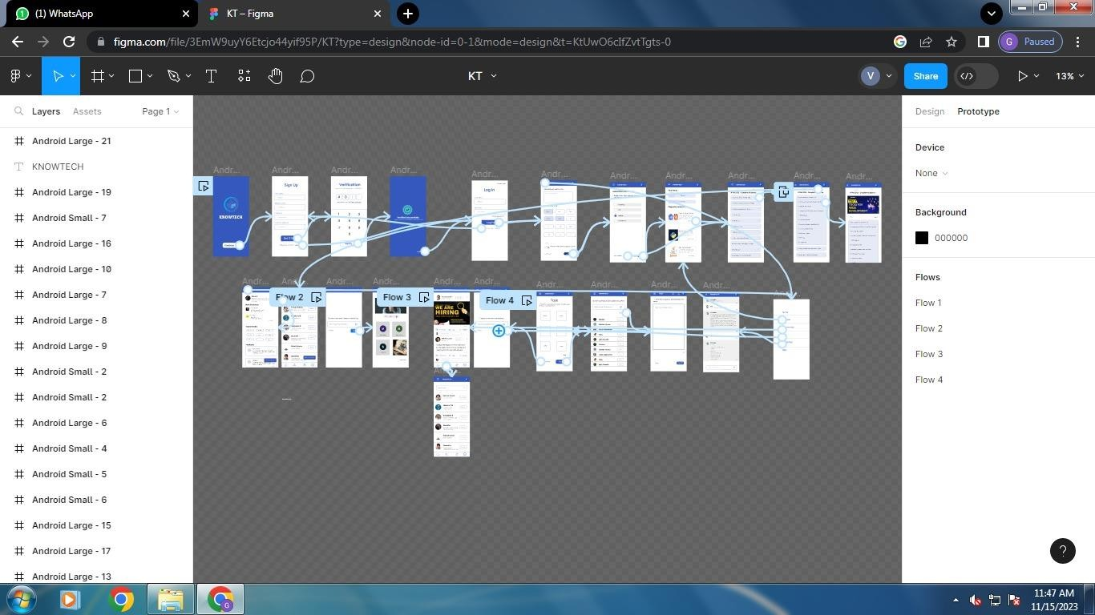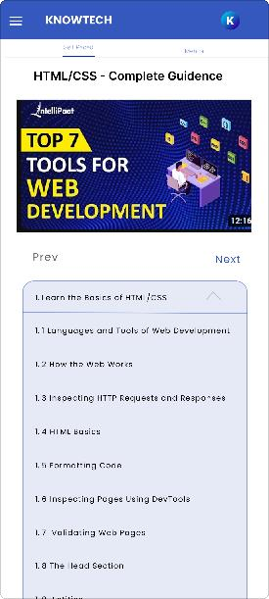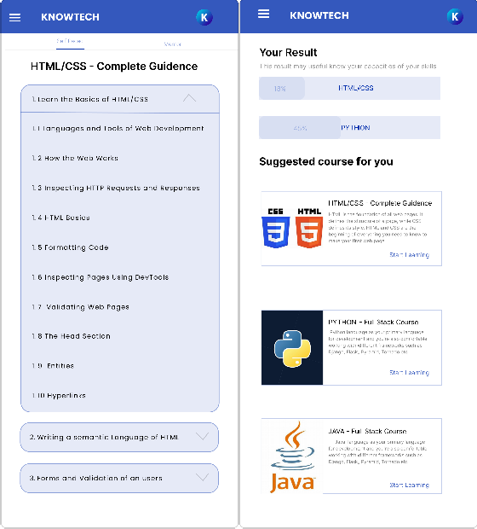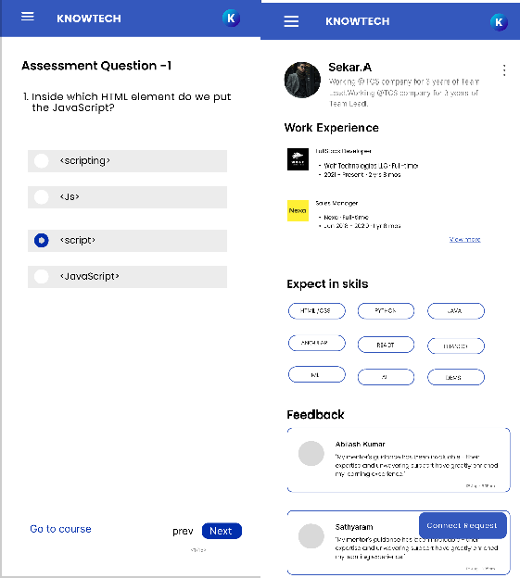

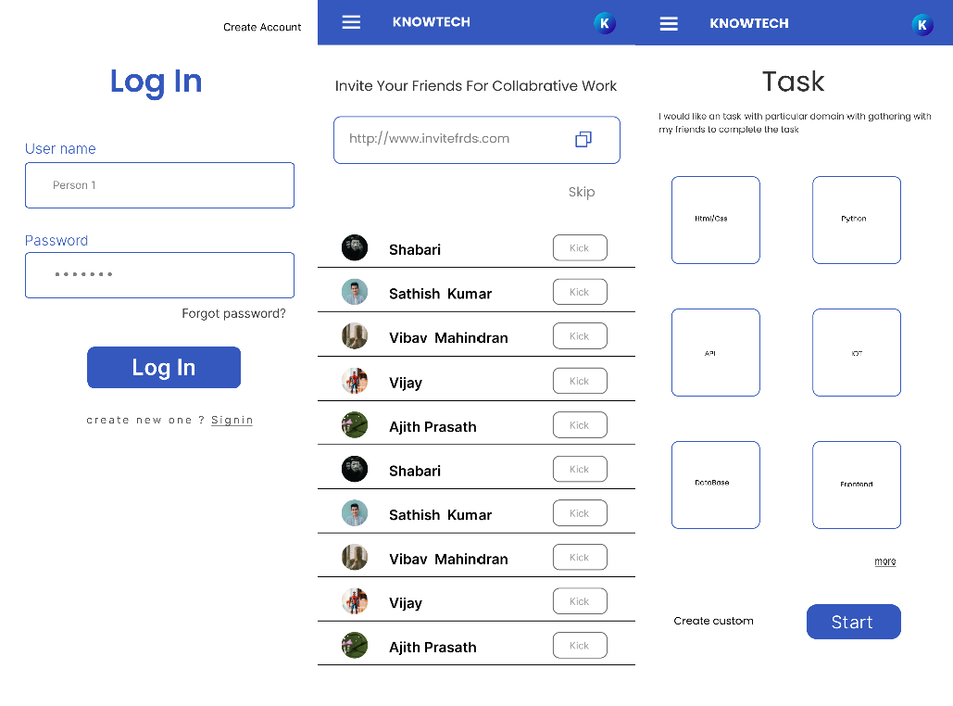

|  |  |  |
| --- | --- | --- |
| **DEPARTMENT OF CSE** | | |
| Performance | 30 |  |
| Observation | 30 |  |
| Record | 40 |  |
| Total | 100 |  |

**Result:**

Thus the brainstorming activity have been conducted successfully for the web application.

|  |  |
| --- | --- |
| **Ex. No: 8** | **Look and Feel of the new Project** |
| **Date:** |

### Aim:

To understand the look and feel of a new project in UI/UX design involves establishing the visual and experiential elements that will shape the user interface and overall user experience.

### Implementation:

1. Understand the Project Goals:
   * Clarify the overall objectives of the project.
   * Identify the target audience and their needs.
2. Gather Inspiration:
   * Research and gather inspiration from existing designs, industry trends, and competitors.
   * Create mood boards or design collections to visualize potential directions.
3. Define Branding Guidelines:
   * Establish or adhere to existing branding guidelines if applicable.
   * Define key elements such as color palette, typography, and logo usage.
4. Create a Design System:
   * Develop a design system that includes reusable components, patterns, and guidelines.
   * Ensure consistency across the entire project.
5. Color Palette:
   * Choose a color palette that reflects the project's brand and evokes the desired emotions.
   * Consider accessibility and contrast for readability.
6. Typography:
   * Select appropriate fonts for headings, subheadings, and body text.
   * Ensure readability and consistency in font choices.
7. Imagery and Icons:
   * Define guidelines for the use of images and icons.
   * Specify the style and tone of visual elements to maintain cohesion.
8. Layout and Grid System:
   * Establish a grid system for layout consistency.
   * Define spacing, margins, and alignments for a structured appearance.
9. Visual Style:
   * Choose an overall visual style, whether it's modern, minimalist, vintage, etc.
   * Consider the project's tone and the emotions you want users to associate with it.
10. User Interface Elements:
    * Define the style of buttons, forms, input fields, and other UI elements.
    * Consider how elements will look in various states (normal, hover, active).
11. Motion and Animation:
    * Decide on the use of motion and animation within the interface.
    * Ensure animations enhance the user experience without being distracting.
12. Microinteractions:
    * Identify opportunities for microinteractions that provide feedback and enhance usability.
    * Define how these interactions align with the overall look and feel.
13. Responsive Design:
    * Plan for responsive design to ensure a consistent experience across different devices.
    * Consider how the design adapts to various screen sizes.
14. User Flow and Navigation:
    * Define the navigation structure and user flow.
    * Determine the style of navigation elements such as menus, buttons, and links.
15. Feedback and Iteration:
    * Gather feedback from stakeholders and team members.
    * Iterate on the design based on feedback to refine the look and feel.
16. Prototype and Test:
    * Create prototypes to visualize the interactions and overall experience.
    * Conduct usability testing to validate the design decisions.
17. Accessibility Considerations:
    * Ensure the design is accessible to users with diverse needs.
    * Follow accessibility standards for color contrast, text legibility, and other factors.
18. Documentation:
    * Document the established design guidelines in a style guide.
    * Provide clear instructions for developers to implement the design.
19. Collaborate with Development:
    * Collaborate closely with developers during the implementation phase.
    * Ensure the design is translated accurately into the final product.
20. User Feedback Loop:
    * Establish a feedback loop with users even after the project launch.
    * Continuously gather insights and make improvements based on user feedback.

By systematically going through these steps, you can define a cohesive and compelling look and feel for your new project, ensuring that it aligns with the project goals and meets the needs of the target audience.

### Output:

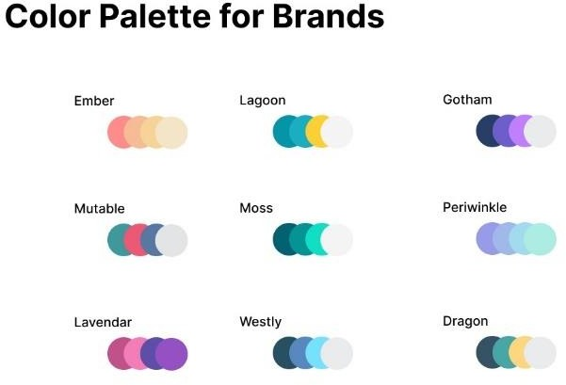

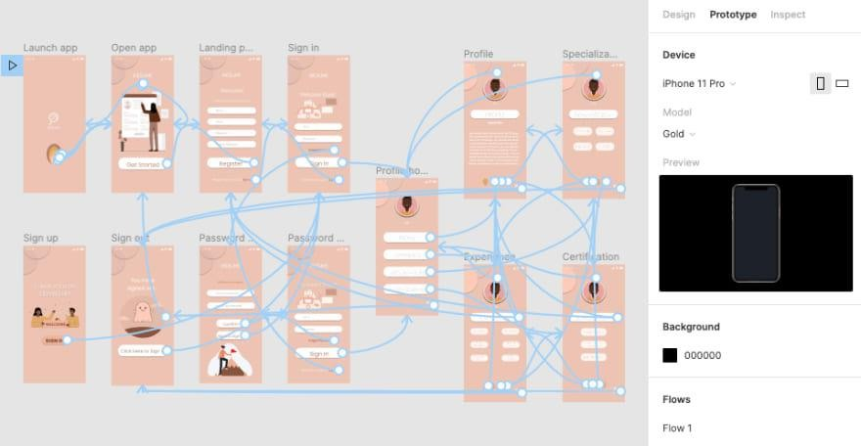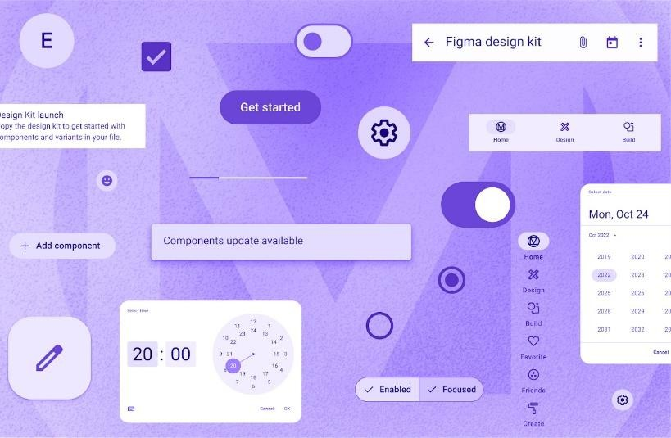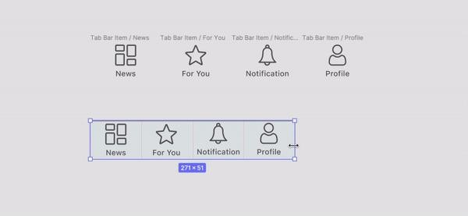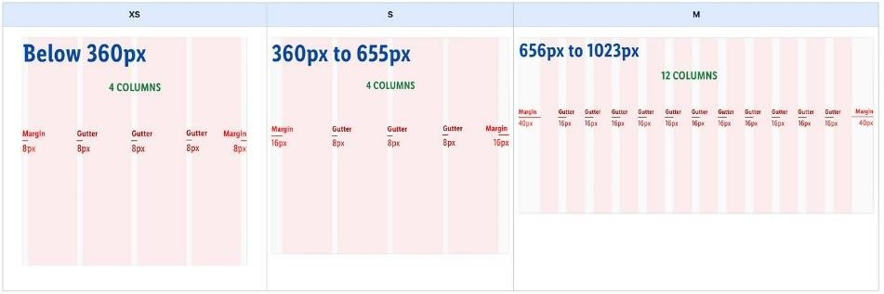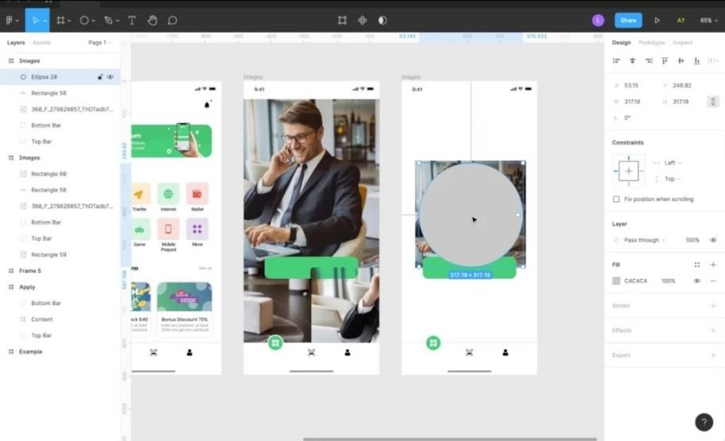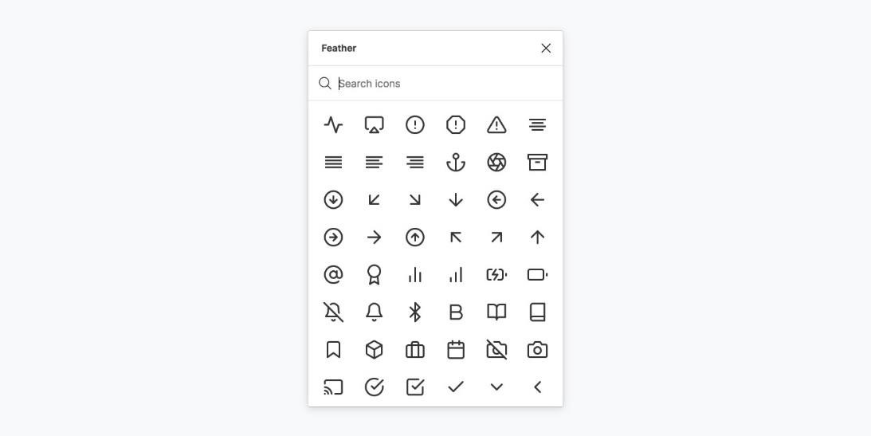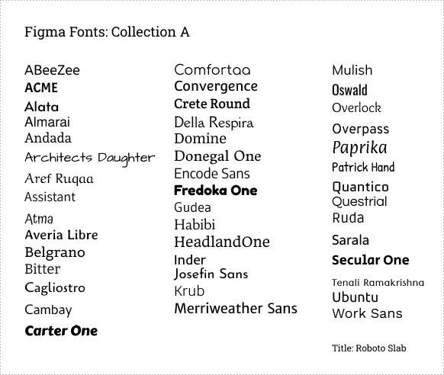

|  |  |  |
| --- | --- | --- |
| **DEPARTMENT OF CSE** | | |
| Performance | 30 |  |
| Observation | 30 |  |
| Record | 40 |  |
| Total | 100 |  |

**Result:**

Thus the look and feel of a new project in UI/UX design involves visual and experiential elements were designed successfully.

|  |  |
| --- | --- |
| **Ex. No: 9** | **Pattern Library** |
| **Date:** |

### Aim:

To create the Pattern Library such as mood board, selecting fonts, and choosing a colour palette based on UI principles is an essential part of the design process.

### Implementation:

Mood Board:

* The mood board reflects the adventurous and exploratory nature of the travel app.
* Images evoke feelings of excitement, outdoor activities, and picturesque destinations.
* The color scheme is inspired by natural elements, and the imagery includes a mix of landscapes, travel essentials, and adventurous activities.

Fonts:

1. Heading Font: Montserrat
   * Montserrat is a modern and clean sans-serif font that exudes a contemporary feel.
   * It is versatile and well-suited for conveying a sense of reliability and modernity.
2. Body Text Font: Roboto
   * Roboto is a readable and neutral sans-serif font.
   * Its versatility makes it suitable for conveying information clearly without distracting from the overall design.

Colors:

Primary Color Palette:

1. Adventure Blue (#0085FF):
   * A vibrant and energetic blue reminiscent of clear skies and vast oceans.
   * Used for primary buttons and accent elements.
2. Forest Green (#2E7D32):
   * A deep green inspired by lush forests.
   * Used for secondary buttons and call-to-action elements.
3. Sunset Orange (#FF6F00):
   * A warm orange reminiscent of a sunset's glow.
   * Used for notifications and highlighting important information.
4. Neutral Gray (#424242):
   * A neutral gray for backgrounds and subtle accents.
   * Provides a balanced contrast with vibrant colors.
5. Cloud White (#FFFFFF):
   * Crisp white for clean backgrounds and legible text.
   * Creates a sense of openness and clarity. Accent Colors:

* Coral Pink (#FF4081):
  + Used sparingly for attention-grabbing elements or notifications.
  + Adds a touch of excitement and contrast.
* Golden Yellow (#FFC107):
  + Used for positive or highlighted elements.
  + Evokes a sense of warmth and positivity. UI Principles:

1. Contrast:
   * Utilizing high contrast between background and text for readability.
   * Contrasting vibrant colors with neutral tones for visual impact.
2. Consistency:
   * Maintaining consistent font styles and sizes for a unified visual language.
   * Consistent use of primary and accent colors throughout the app.
3. Hierarchy:
   * Establishing a clear hierarchy through font weights, sizes, and color contrasts.
   * Ensuring important elements stand out while maintaining a logical flow.
4. Readability:
   * Prioritizing legibility with a clean and modern font choice.
   * Ensuring sufficient contrast between text and background colors.
5. Accessibility:
   * Checking color combinations for accessibility, especially for users with visual impairments.
   * Using an accessible font size and spacing for comfortable reading.

### Output:

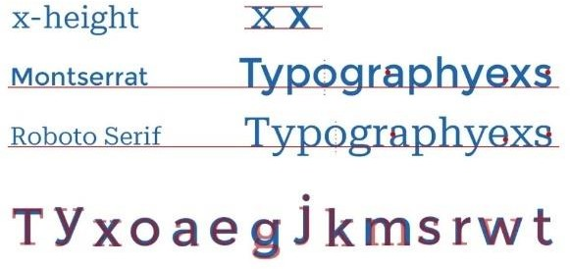

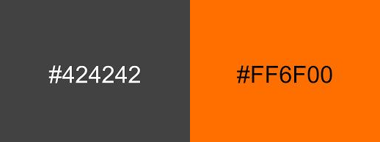

|  |  |  |
| --- | --- | --- |
| **DEPARTMENT OF CSE** | | |
| Performance | 30 |  |
| Observation | 30 |  |
| Record | 40 |  |
| Total | 100 |  |

Result:

Thus the Pattern Library such as mood board, selecting fonts, and choosing a colour palette were created.

|  |  |
| --- | --- |
| **Ex. No: 10** | **Identify the Customer Problem** |
| **Date:** |

### Aim:

To Identify the Customer Problem in Mobile Application.

### Implementation:

Customer Problem: Difficulty in Planning and Tracking Personal Finances Description:

Many individuals find it challenging to effectively plan and track their personal finances. This can lead to

overspending, insufficient savings, and financial stress. While various finance apps exist, some users still struggle to find a solution that is user-friendly, intuitive, and tailored to their specific needs. Managing budgets, tracking expenses, and understanding financial goals can be complex tasks, and there's an opportunity to create a mobile app that simplifies this process.

Proposed Mobile App Solution:

Name: FinEase Key Features:

1. Intuitive Budgeting:
   * Simplify the budgeting process with a user-friendly interface.
   * Allow users to set spending limits for different categories.
2. Expense Tracking:
   * Enable easy input and categorization of expenses.
   * Provide visualizations and reports to help users understand their spending patterns.
3. Financial Goal Setting:
   * Allow users to set short-term and long-term financial goals.
   * Provide progress tracking and reminders to stay on track.
4. Automated Savings:
   * Integrate features for automated savings based on user-set parameters.
   * Provide suggestions on potential areas for cost-cutting.
5. Financial Education:
   * Include educational content on budgeting, investing, and financial planning.
   * Offer tips and resources to improve users' financial literacy.
6. Sync Across Devices:
   * Enable users to sync their financial data across multiple devices for seamless access.
   * Ensure data security and privacy.
7. Customizable Alerts:
   * Allow users to set personalized alerts for budget limits, upcoming bills, and goal milestones.
   * Enhance proactive financial management.
8. Community Support:
   * Introduce a community feature where users can share tips, success stories, and challenges.
   * Foster a sense of accountability and support. How the Mobile App Solves the Problem:

FinEase aims to simplify the often complex process of personal finance management by providing an intuitive and comprehensive solution. By combining budgeting, expense tracking, goal setting, and educational resources in one app, FinEase empowers users to take control of their finances. The app's user- friendly design and customizable features cater to a broad audience, making financial planning accessible to both beginners and experienced users.

This mobile app design addresses the identified customer problem by providing a holistic and user-centric solution to personal finance management.

### Output:

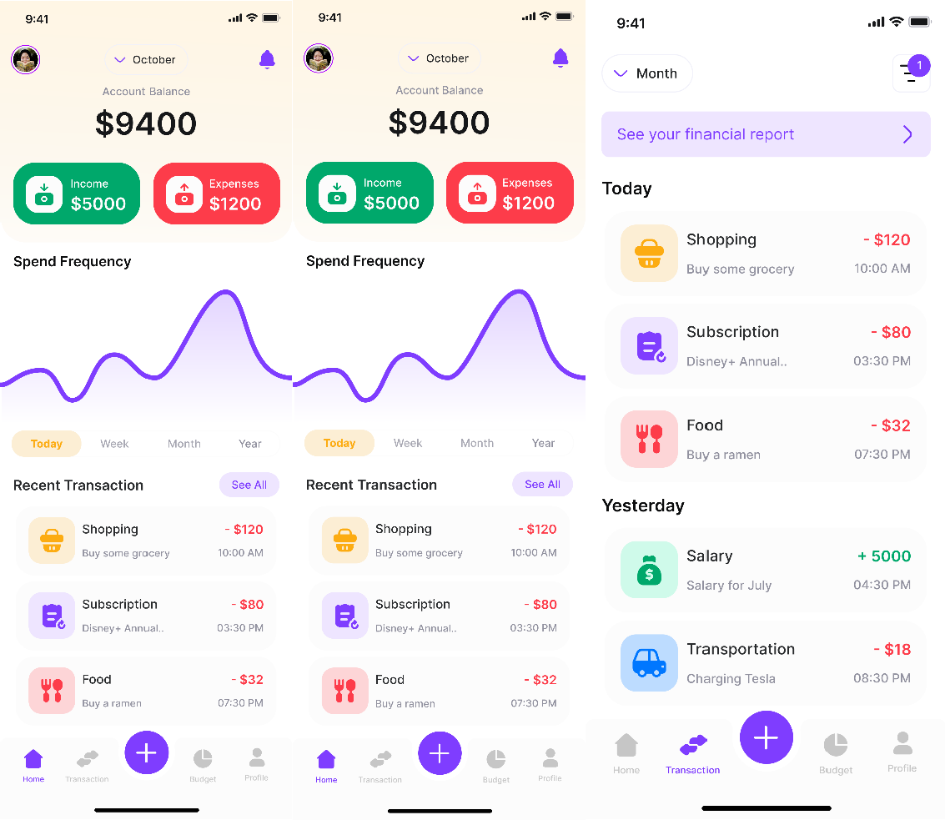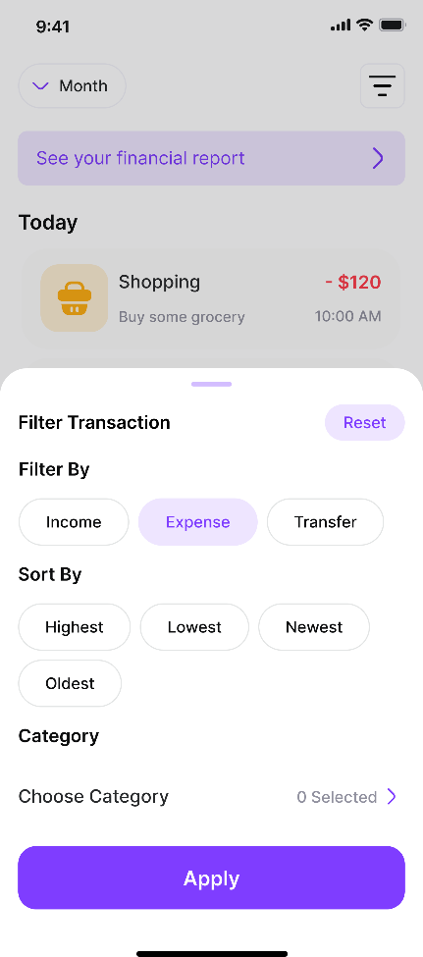

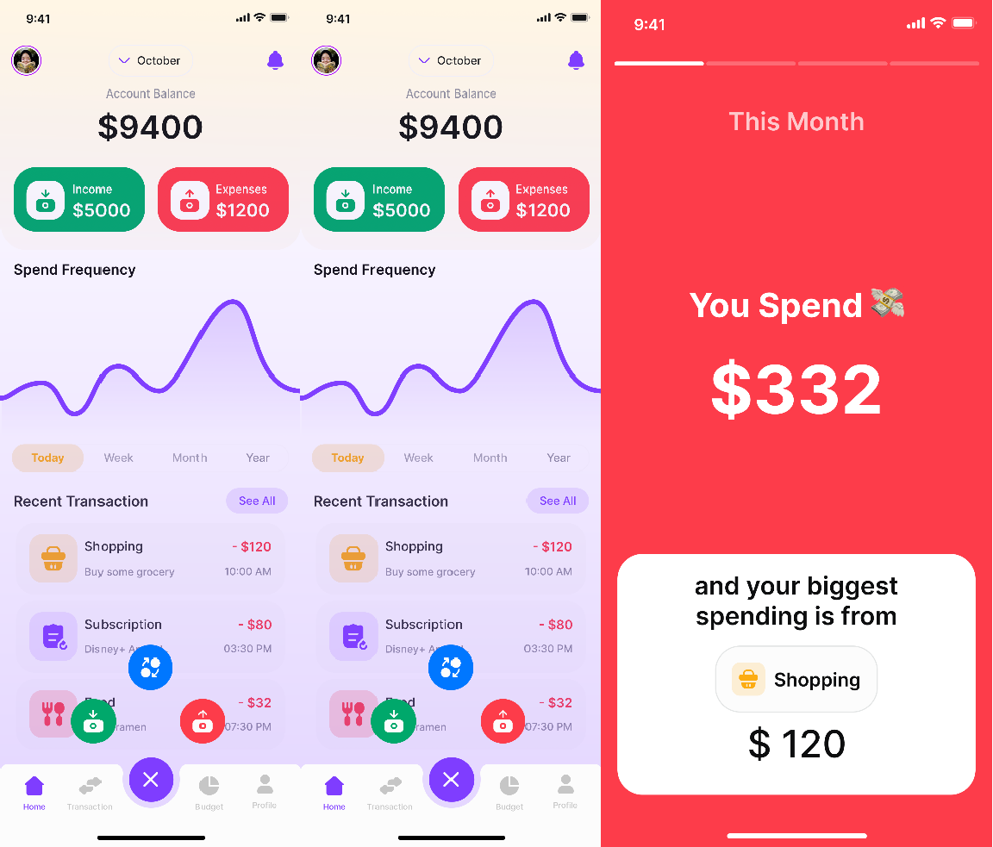

|  |  |  |
| --- | --- | --- |
| **DEPARTMENT OF CSE** | | |
| Performance | 30 |  |
| Observation | 30 |  |
| Record | 40 |  |
| Total | 100 |  |

**Result:**

Thus the difficulty in planning and tracking the customer problem in mobile application is identified and solved successfully.

|  |  |
| --- | --- |
| **Ex. No: 11** | **End-to-end User Research** |
| **Date:** |

### Aim:

Conducting end-to-end user research and incorporating user personas, ideation processes, flow diagrams, and flow mapping is a comprehensive approach to designing user-centric solutions.

Let's go through each step:

1. User Research:
   * Objective: Understand user needs, behaviors, and pain points.
   * Methods:
     + Conduct interviews with potential users to gather insights.
     + Use surveys and questionnaires to collect quantitative data.
     + Analyze existing analytics data if applicable.
2. Creating Personas:
   * Objective: Develop detailed user personas based on research findings.
   * Process:
     + Identify common patterns and characteristics from user research.
     + Create fictional but representative personas embodying these traits.
     + Include details such as demographics, goals, challenges, and preferences.
3. Ideation Process:
   * Objective: Generate ideas for addressing user needs and pain points.
   * Methods:
     + Conduct brainstorming sessions with cross-functional teams.
     + Use techniques like mind mapping to explore interconnected concepts.
     + Encourage diverse thinking and consider both incremental and innovative ideas.
4. User Stories:
   * Objective: Define specific user needs and the value proposition of the solution.
   * Process:
     + Develop user stories that articulate tasks users want to accomplish.
     + Use the "As a [user], I want [action] so that [benefit]" format.
     + Ensure stories cover a range of user personas and scenarios.
5. Scenarios:
   * Objective: Create narratives that illustrate how users interact with the solution.
   * Process:
     + Develop scenarios based on user stories to showcase the user journey.
     + Include different paths and variations to account for diverse user interactions.
     + Highlight pain points and moments of delight.
6. Flow Diagrams:
   * Objective: Visualize the user flow and system interactions.
   * Process:
     + Use flowchart symbols to represent steps, decisions, and outcomes.
     + Map out the entire user journey from entry point to goal completion.
     + Consider alternative paths and decision points.
7. Flow Mapping:
   * Objective: Create a comprehensive visual representation of the user experience.
   * Process:
     + Combine flow diagrams, user stories, and scenarios into a cohesive map.
     + Highlight touchpoints, user interactions, and system responses.
     + Incorporate feedback loops and areas for potential iteration.
8. Validate and Iterate:
   * Objective: Ensure that the proposed solution aligns with user needs.
   * Process:
     + Conduct usability testing with prototypes.
     + Gather feedback from real users and stakeholders.
     + Iterate on designs based on feedback to improve the user experience.
9. Documentation:
   * Objective: Document key findings, decisions, and design rationale.
   * Process:
     + Create a comprehensive document that captures the user research process, persona details, ideation outcomes, user stories, and flow diagrams.
     + Use this documentation as a reference for the development team and future iterations.

### Output::

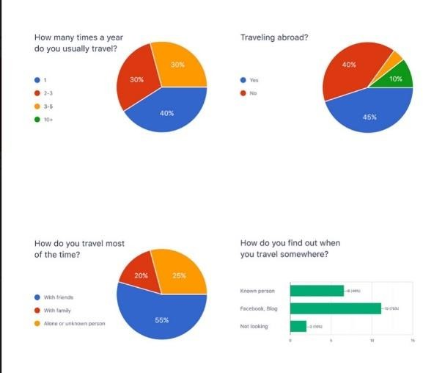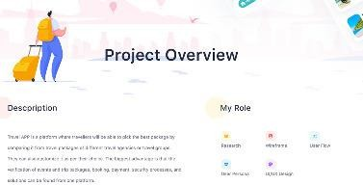

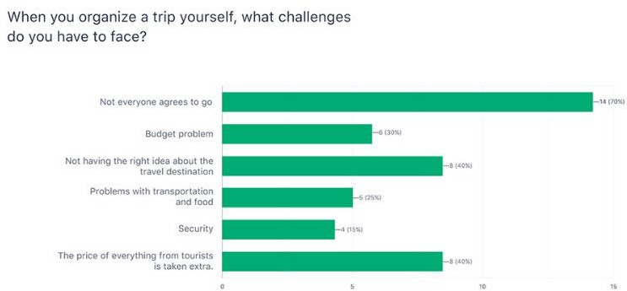

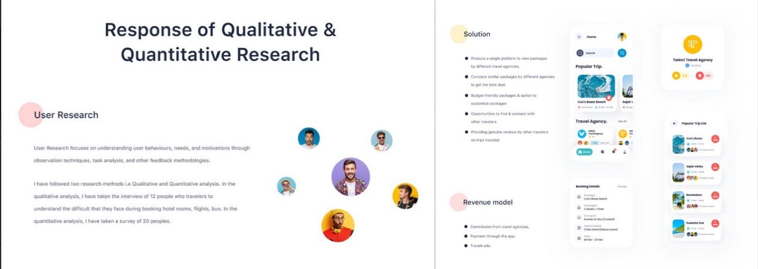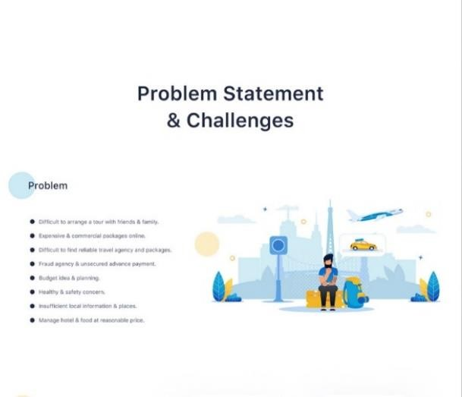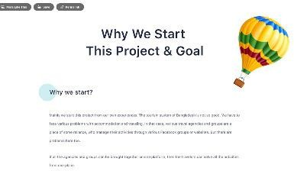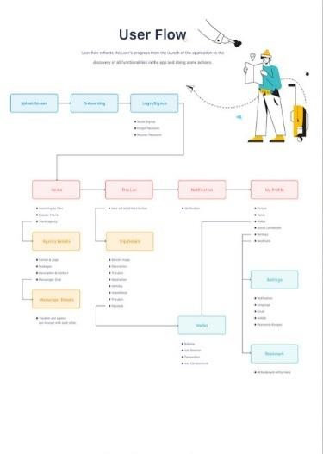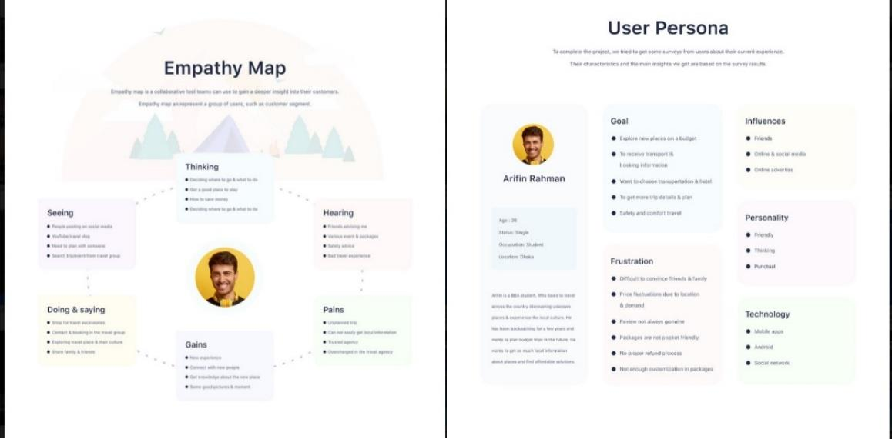

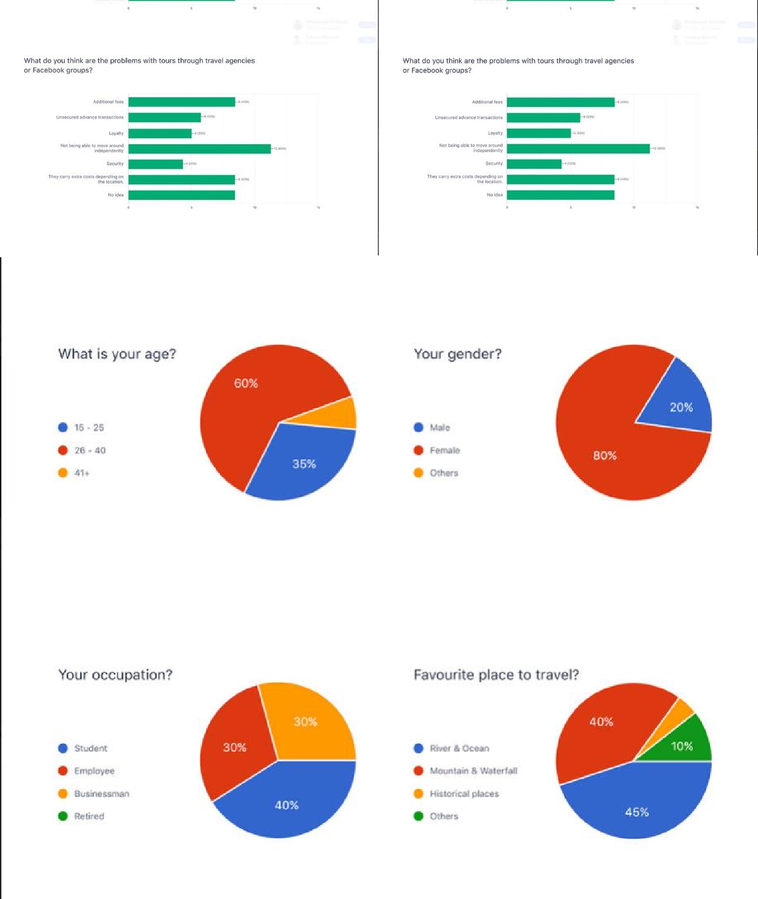

|  |  |  |
| --- | --- | --- |
| **DEPARTMENT OF CSE** | | |
| Performance | 30 |  |
| Observation | 30 |  |
| Record | 40 |  |
| Total | 100 |  |

**Result:**

Thus, the end-to-end user research and incorporating user personas, ideation processes, flow

diagrams, and flow mapping have been prepared for designing an user-centric solutions.

|  |  |
| --- | --- |
| **Ex. No: 12** | **Sketch, design with popular tool and build a prototype** |
| **Date:** |

### Aim:

To understand the process of sketching, designing with a popular tool, building a prototype, performing usability testing, and identifying improvements for a fictional finance app named "FinanceHub."

### Implementation:

1. Sketch:
   * Objective: Conceptualize the layout and key features of the FinanceHub app.
   * Tools:
     + Pen and paper or digital sketching tools like Procreate or Adobe Sketch.
   * Process:
     + Sketch out the main screens, including the dashboard, budgeting, expense tracking, and goal setting.
     + Outline basic user flows and interactions.
2. Design with a Popular Tool:
   * Objective: Translate sketches into a digital format using a design tool.
   * Tools:
     + Figma, Sketch, Adobe XD, or other popular UI/UX design tools.
   * Process:
     + Create high-fidelity wireframes for each screen.
     + Design detailed UI elements, including buttons, icons, and navigation.
     + Ensure consistency with fonts, colors, and branding.
3. Build a Prototype:
   * Objective: Develop an interactive prototype to simulate user interactions.
   * Tools:
     + Figma, Sketch, Adobe XD, or tools specifically for prototyping like InVision or Proto.io.
   * Process:
     + Link screens to create a navigable prototype.
     + Add interactive elements such as buttons and transitions.
     + Test the flow to ensure a seamless user experience.
4. Perform Usability Testing:
   * Objective: Gather feedback on the usability and user experience of the prototype.
   * Methods:
     + In-person or remote usability testing with target users.
     + Use a combination of observation, interviews, and surveys.
   * Process:
     + Provide users with specific tasks to accomplish within the prototype.
     + Observe user interactions and note areas of confusion or frustration.
     + Collect qualitative and quantitative data on user satisfaction.
5. Identify Improvements:
   * Objective: Analyze usability testing results and identify areas for improvement.
   * Process:
     + Review feedback from users regarding pain points and positive experiences.
     + Identify patterns and common issues across multiple users.
     + Prioritize improvements based on severity and impact on user experience.

Usability Testing Findings and Improvements:

1. Feedback:
   * Issue: Users found the onboarding process confusing.
   * Improvement: Simplify the onboarding steps, provide clearer instructions, and include tooltips for first- time users.
2. Navigation:
   * Issue: Some users struggled to find the budgeting and goal-setting features.
   * Improvement: Improve navigation visibility, consider adding a bottom navigation bar for easy access to core features.
3. Data Entry:
   * Issue: Users had difficulties categorizing transactions.
   * Improvement: Streamline the data entry process, introduce auto-categorization, and provide smart suggestions.
4. Graphical Representation:
   * Issue: Users wanted more visualizations on the dashboard.
   * Improvement: Enhance the graphical representation of income, expenses, and savings on the dashboard for a quick overview.
5. Accessibility:
   * Issue: Users with visual impairments faced challenges with the app's contrast.
   * Improvement: Improve color contrast, provide alternative text for images, and ensure compatibility with screen readers.
6. Notifications:
   * Issue: Users missed important alerts about upcoming bills.
   * Improvement: Implement customizable notification preferences and reminders, allowing users to set the timing and frequency of alerts.
7. Performance:
   * Issue: Some users experienced slow loading times.
   * Improvement: Optimize app performance, compress images, and minimize unnecessary data requests.
8. Security Reassurance:
   * Issue: Users expressed concerns about the security of their financial data.
   * Improvement: Enhance in-app security features, communicate encryption practices during onboarding, and provide a link to the privacy policy.
9. Iterate on the Prototype:
   * Objective: Incorporate identified improvements into the prototype.
   * Process:
     + Make necessary adjustments based on the feedback received.
     + Update the prototype with improved navigation, clearer instructions, and enhanced visual elements.
     + Ensure that changes align with the overall design language.
10. Re-test and Validate:
    * Objective: Validate the effectiveness of implemented improvements.
    * Process:
      + Conduct a second round of usability testing with the updated prototype.
      + Collect feedback on the specific areas that were improved.
      + Measure user satisfaction and task success rates.
11. Documentation:
    * Objective: Document the changes made and lessons learned.
    * Process:
      + Create a summary document detailing the usability testing process, identified issues, implemented improvements, and testing results.
      + Use this document for reference in future design iterations.

**Output:**

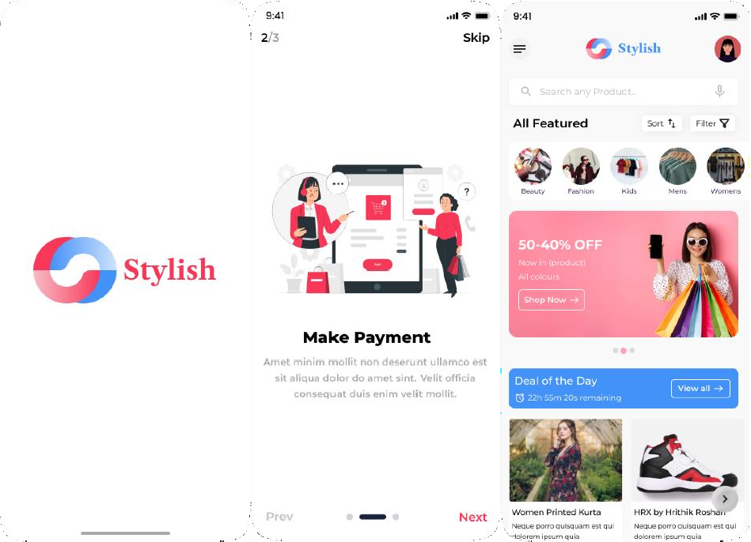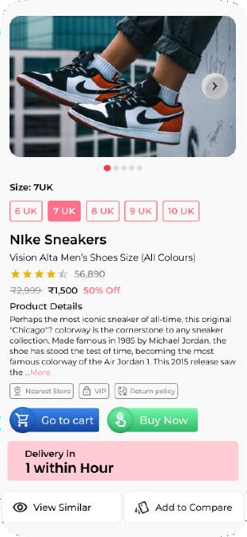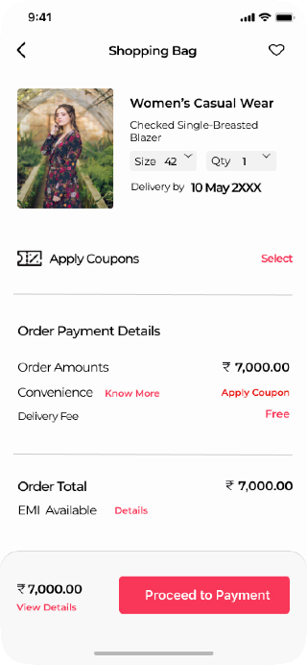

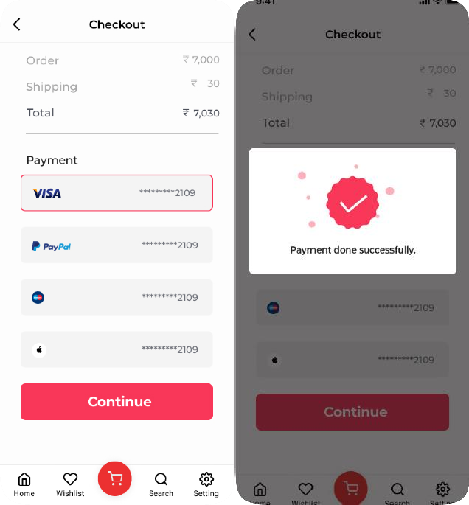

|  |  |  |
| --- | --- | --- |
| **DEPARTMENT OF CSE** | | |
| Performance | 30 |  |
| Observation | 30 |  |
| Record | 40 |  |
| Total | 100 |  |

## Result:

Thus we understand the process of sketching, designing with a popular tool, building a prototype, performing usability testing, and identifying improvements for a fictional finance app named "FinanceHub” successfully.